Griffin Baumberger
Griffin Marshall
Justin Song
Adrienne Berry

Title
A Study of the behavior and habitat of Terrapene C. Carolina on the campus on The Lovett School
Abstract
A. What are the objectives of the study?
The purpose of this study is to study the population of eastern box turtles on Lovett’s campus and to determine whether their population is healthy and stable. Another objective is to determine the size and location of each turtle’s home range.
B. How was the study done?
The study was conducted using radio telemetry to track the location of a turtle on Lovett’s campus. The turtle was attached to an electronic transmitter and was allowed to roam free around it’s habitat. Every week, the turtle would be tracked using a receiver that picked up signals from the transmitter. Once the turtle was found, the capture site would be marked. After 12 separate captures, a map could be created that accurately outlines the turtle’s home range. This same process was done with each turtle in the study.
C. What results were obtained?
The results that were obtained from the study indicate that the box turtles are able to live in the environment that they are currently living in. From the past, there has been a low death rate from the box turtles that were tracked and monitored. Only three deaths have been reported. A unique home range was determined for each individual turtle.
D. What is the significance of the results?
Discovering that the death rate of Lovett box turtles is significant because it is an indicator that Lovett is doing all the right things in order to ensure the well being and good health of the box turtles. The results show that the current environment that Lovett currently offers for the box turtle is good enough to sustain the current box turtle generation along with the future generations of box turtles in years to come. In addition, knowing the home range of a box turtle is important because it allows researchers to understand the specific parts of the environment where the box turtles prefer to live. This allows researchers to gain a further understanding of what types of environments box turtles can thrive in and which environments they cannot thrive in. It will also allow researchers to be able to protect the box turtles better.

Introduction
Several studies, including but not limited to this one, analyze the movement and habitat of eastern box turtles (terrapene carolina carolina) by using radio telemetry. The study Home Range and Movement of Blanding’s Turtles (Emydoidea blandingii) in New Hampshire stated that female turtles moved the most during the month of June and then moved the least in December due to hibernation. Because of hibernation, when the turtles buried underground, the turtles had no movement over the next month or so. However, according to Eastern Box Turtle (Terrapene carolina carolina) Movements in a Fragmented Landscape, the movement of the turtle depends on study area isolation. Thus, “males in the isolated study areas moved shorter distances daily,” while females had no difference in isolation versus non-isolation movement (105). This study concludes that males moved less freely in isolated areas and more freely in non-isolated areas, while females moved more when they are about to give birth in both isolated and non-isolated areas. Nevertheless, Movements of the Box Turtle, Terrapene c. carolina (Linnaeus) in Unfamiliar Territory reports that turtles move in only one direction. Thus, “periods of unidirectional movement were only affected by obstacles along the path” such as cars, people, and other animals (781). According to Natural History of Terrapene carolina (Box Turtles) in an Urbanized Landscape, from May of 1999 until September 2004, “we collected 365 turtles, 342 of them which were alive” and then studied the activity and condition of these turtles and how an urban environment impacted them (194). Their study concluded that the more forest cover there is, the longer the turtle lives. 55% of 20+ year old turtles lived in a 90%-100% forest covered area, while 40% of the turtles from the ages of 0-4 lived in a 0%-20% forest covered area. Another article, Population Ecology of the Eastern Box Turtle in a Fragmented Landscape, says that “human disturbances, isolation, and habitat composition appear to have the greatest influence on the box turtle populations we studied” (745). The article concludes that the best way to avoid human interaction with turtles is to plant crops next to forest habitats “that require no mowing” (745).
Therefore, our current study of scientific interest is to observe the movement and habitat of our turtle, while at the same time recognizing its hibernation period, one direction of movement, non-isolation on our school’s campus, urban environment, and human disturbances of the turtle. Our study covers the lifestyle patterns of our turtle and how outside forces affect it. However, our study specifically contributes how we can better our school’s environment in which box turtles are welcomed and consequently help them live longer. Thus we bring how we can better the environment for our turtle population’s health to the table. Our goal is to track the movements and the home range of the eastern box turtle (terrapene carolina carolina) by using radio telemetry in an urban environment over a time period of 5 months so we can better understand how the turtle lives on our school’s campus and help the turtle population on campus in the future.
Materials and Methods

In the beginning of this experiment, box turtles were captured from areas inside the Lovett School campus in several different valleys. In total, 77 turtles (34 female, 40 male) were found in 7 different valleys. When a turtle was found, it was carried back to the lab, where a baseline data sheet was written and completed. During this time, the turtle was kept in a tub with dirt, foliage, and food for a week while the researchers recorded baseline data for the turtle. The turtle was first sexed by looking at the color of the eyes (males have red rings in the eyes, females have brown), and by looking at the concavity of the plastrons (males have concave plastrons so that they can mount females, and females have flat plastrons). The length, width, and depth of the turtle was measured in centimeters. The turtles weight was measured in grams by putting the individual turtle on a scale upside down so that it would not climb off. The valley of the turtle was recorded and the actual location where it was found was written down so that the researches could put the turtle back as close as possible to its home location. Descriptions of the turtle’s injuries, significant markings, and coloring of it’s shell was taken. The turtle was then compared to pictures of other turtles to see if the turtle had been captured before, and if it had, then the baseline data was added to the current information. If the turtle had not been captured before, then the turtle was named and a new set of data started to be recorded.
Once the data for the turtle was sufficiently collected and recorded, the turtles were cleaned off so that no dirt or debris was on the turtle’s shell. Then, a radio transmitter was attached to the turtles back shell so that it could be found repeatedly throughout the experiment. First, Velcro with adhesive material on the bottom was attached to the back shell of the turtle, towards its tail. The other Velcro was then wrapped around the radio transmitter so that the two sides of the Velcro could attach easily. The transmitter was then attached to the turtle, but not in a very secure manner. Next, camouflaged duct tape was applied to the transmitter on the turtle tightly so that the transmitter was reinforced. The tape and Velcro was applied so that the turtle did not have any walking impairments. Then, the turtles were placed back into the valley as close to where they were found as possible. After a week of being in the wilderness, the researchers went out and used radio telemetry to find the turtle. Once the turtle was found, the date, time, and location of the turtle was recorded in a Telemetry Data Sheet. A flag was then tied around a tree or other stationary object that would indicate exactly where the turtle was found. The date and number of the find were written on the flag.
After 12 finds, approximately one week apart, the tape, Velcro, and transmitter were removed from the turtle and it was returned to its natural environment. Researchers then went back into the valley and recorded on a map where every single turtle find was by using the identifying flags. Notable landmarks, trees, and infrastructure were also recorded on the map so that the map could be as accurate as possible. Once the locations of the finds were marked down, the identifying flags were removed from the trees and thrown away. All human waste that could have been in the valleys was also removed. The turtle’s home range acreage was then measured on the map and recorded with the rest of the turtle’s baseline data.
The materials used were tubs that housed the turtles while baseline data was recorded, baseline data sheets, radio transmitters, receivers, antennas, Velcro, duct tape, identifying flags, and lots of bug spray.

Results

- Number of Males vs Females:
40 Males, 34 Females

- Total Number of Box Turtles:
74 box turtles

- Number Captured/Year, Number of New Captures/ Year, Number of Recaptures/Year
Male Box Turtles: Figure 1.1
Year | Captured: | New: | Recaptured:
2005 | 10 | 10 | 0
2006 | 4 | 4 | 0
2007 | 12 | 8 | 4
2008 | 7 | 5 | 2
2009 | 8 | 1 | 7
2010 | 11 | 4 | 7
2011 | 7 | 3 | 4
2012 | 6 | 3 | 3
2013 | 14 | 2 | 12
Totals: | 79 | 40 | 39

Female Box Turtles: Figure 1.2
Year | Captured: | New: | Recaptured:
2005 | 5 | 5 | 0
2006 | 4 | 3 | 1
2007 | 6 | 6 | 0
2008 | 6 | 5 | 1
2009 | 6 | 5 | 1
2010 | 8 | 2 | 6
2011 | 6 | 2 | 4
2012 | 3 | 0 | 3
2013 | 8 | 6 | 2
Totals: | 52 | 34 | 18

- Population Estimate: Figure 2.1
(Total # Captured 2005-2012 + 1) x (Total # Captured 2013 + 1)
------------------------------------------------------------------------------------
(# of Recaptures 2013-1)

$$(65+44+1)(14+8+1)/(12+2-1)= 194.615 turtles$$
The estimation is that there are 194 turtles in the Lovett School habitat.

- Mean Home Range and Variance: Figure 3.1
Mean (average) Home Range: $21.83 acres/29 box turtles = 0.7526 acres$
Smallest home range: 0.02 → Biggie Smalls
Largest home range: 1.63 → Latisha
Variance $1.63 acres-.02 acres= 1.61 acres$

- Map of specific turtle “Latisha” home range: Figure 4.1
The acreage of Latisha’s home range this year is 1.179 acres. The key, additional information, and larger map can also be found at (http://imgur.com/a/ER4us) 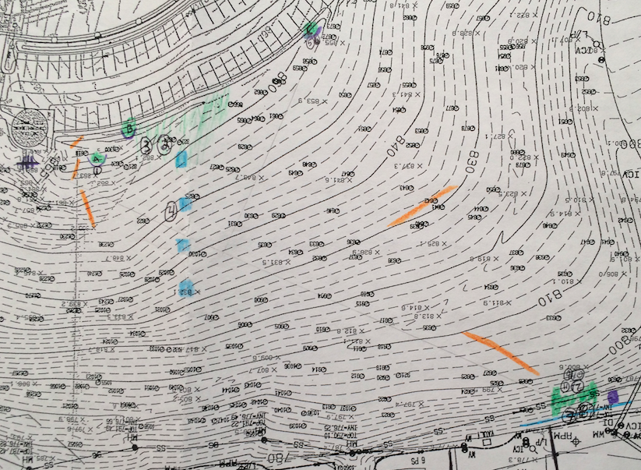

Discussion
The data collected during the study are classified as either observations or simply as numerical information. Observations do not involve any numbers and give us information such as movement patterns, general diet, and habitat preference. The numerical information tells us information involving numbers such as the number of box turtles that have been captured in Lovett, weight, length, width, and the size of home ranges. Both classifications of the data collected tell us different things.
The observations gave us important information that the numbers alone could not tell us. Observing the box turtle gave us a better understanding of their behavior within its home range. By observing our box turtle in its home range we were able to figure out how it acted within its area and what different kinds of food sources are available in the area It also allows us to understand what is specifically causing box turtles to be healthy or to be damaging.
The numerical information gave us the physical characteristics of the box turtles within Lovett’s campus. The average male length is 12.3 centimeters long while the average female length is about 11.51 centimeters long. According to the Virginia Herpetological Society, the average length of box turtles is between 11.5 - 15.2 centimeters, indicating that the box turtles at Lovett are relatively healthy as they are within the average length. The average male weight is around 368.5 grams while the average female weight is around 346.8 grams. This information is important because it tells us information on the well-being and the overall physical health of the box turtles.
During the study, 40 males and 34 females were captured. This is a healthy amount of box turtles because they are neither overpopulated or scarce. Overpopulation can lead to a scarcity in the amount of food available, and a low population has the potential to be exterminated in the event of disease or predation. The ratio of males to females is close to one. The average size for a Lovett turtle’s home range is 0.7526 acres. The largest home range measured was Latisha’s, at 1.63 acres. The smallest is that of Biggie Smalls, with a home range of .02 acres. The variance in home range size is 1.61 acres. This shows that there is a wide range of home range sizes for each individual box turtle.
Using the population/recapture equation in Figure 2.1, we can accurately predict that there are about 194 turtles on campus property. Using this data, we can draw conclusions about the environment that these animals live in. Judging by the large number of turtles predicted to living in Lovett’s habitat, we know that this habitat is suitable enough for living. There is enough evidence to show that the turtles have ample food, water, and shelter to steadily grow their population.

Literature Cited

- Bernstein, Neil P., Rebecca J. Rightsmeier, Benjamin R. Montgomery, and Robert W. Black. "Home Range and Philopatry in the Ornate Box Turtle, Terrapene Ornata Ornata, in Iowa." American Midland Naturalist 157.1 (2007): 162-74. JSTOR. Web. <http://www.jstor.org/stable/4500603>.
- Budischak, Sarah A., Joy M. Hester, Steven J. Price, and Michael E. Dorcas. "Natural History of Terrapene Carolina (Box Turtles) in an Urbanized Landscape." Southeastern Naturalist 5.2 (2006): 191-204.JSTOR. Web. <http://www.jstor.org/stable/3878201>.
- Claussen, Dennis L., Paul M. Daniel, Suping Jiang, and Nadine A. Adams. "Hibernation in the Eastern Box Turtle, Terrapene C. Carolina." Journal of Herpetology 25.3 (1991): 334-41. EBSCO. Web.
- Iglay, Raymond B., Jacob L. Bowman, and Nathan H. Nazdrowicz. "A Comparison of Two Methods for Studying Box Turtle Movements."Wildlife Society Bulletin 34.1 (2006): 208-10. JSTOR. Web.
- Iglay, Raymond B., Jacob L. Bowman, and Nathan H. Nazdrowicz. "Eastern Box Turtle (Terrapene Carolina Carolina) Movements in a Fragmented Landscape." Journal of Herpetology 41.1 (2007): 102-06.JSTOR. Web. <http://www.jstor.org/stable/4498557>.
- Innes, Robin J., Kimberly J. Babbitt, and John J. Kanter. "Home Range and Movement of Blanding's Turtles (Emydoidea Blandingii) in New Hampshire." Northeastern Naturalist 15.3 (2008): 431-44. Ebsco. Web.
- Lemkau, Philip J. "Movements of the Box Turtle, Terrapene C. Carolina (Linnaeus) in Unfamiliar Territory." Copeia 1970.4 (1970): 781-83. JSTOR. Web. <http://www.jstor.org/stable/1442333>.
- Marsack, Kelly, and Bradley J. Swanson. "A Genetic Analysis of the Impact of Generation Time and Road-Based Habitat Fragmentation on Eastern Box Turtles (Terrapene C. Carolina)." Copeia 2009.4 (2009): 647-52. JSTOR. Web. <http://www.jstor.org/stable/25622954>.
- Miller, Kirk, and Geoffrey F. Berchard. "Influence of Body Size on Shell Mass in the Ornate Box Turtle, Terrapene Ornata." Journal of Herpetology 39.1 (2005): 158-61. JSTOR. Web. <http://www.jstor.org/stable/4092967>.
- Nazdrowicz, Nathan H., Jacob L. Bowman, and Roland R. Roth. "Population Ecology of the Eastern Box Turtle in a Fragmented Landscape." The Journal of Wildlife Management 72.3 (2008): 745-53.JSTOR. Web. <http://www.jstor.org/stable/25097604>.

